Multi-Agent Market Research and GTM Planning (n8n, MCP, and CrewAI)

Overview
In this project, you will design and implement a multi-agent workflow system that automates market research and go-to-market (GTM) planning.
You will implement the same workflow in two ways:
- n8n workflow with Google integration
- CrewAI project with CLI + Streamlit interface
Both versions use a Head Analyst Agent to orchestrate three specialized sub-agents:
- Research Agent: Finds authoritative sources
- Analyst Agent: Creates competitor tables & insights
- GTM Agent: Drafts strategy sections
The output is a structured Google Doc containing the research, analysis, and GTM strategy. The document is then optionally emailed to the user via Gmail.

Architecture overview
The workflow consists of:
- Chat Trigger: Entry point for user messages
- Head Analyst (AI Agent1): Main orchestrator agent
- Three Sub-Agents as Tools:
  - Research Agent (connected to MCP tool)
  - Analyst Agent (connected to SerpAPI)
  - GTM Agent (connected to SerpAPI)
- Google Services: Document creation/update and Gmail integration
- Gemini AI: Powers all agents

Prerequisites
- n8n instance (self-hosted or cloud)
- Google Cloud Console account
- SerpAPI key
- Gemini API key
- MCP tool access

Step 1: Google Cloud Console setup

1.1 Create OAuth 2.0 credentials
- Navigate to Google Cloud Console
- Create a new project or select an existing one
- Go to APIs & Services → Credentials
- Click + CREATE CREDENTIALS → OAuth client ID
- Configure the OAuth consent screen if prompted:
  - Choose "External" or "Internal" based on your needs
  - Fill in required application information
- For Application type, select Web application or Desktop app based on your n8n setup:
  - Web application: If n8n is hosted on a server
  - Desktop app: If running locally
- Add authorized redirect URIs (for web application):
  - https://your-n8n-instance.com/rest/oauth2-credential/callback
  - For local development: http://localhost:5678/rest/oauth2-credential/callback
- Save your Client ID and Client Secret

1.2 Enable APIs and configure sign-in
- In Google Cloud Console, go to APIs & Services → Library
- Search and enable the following APIs:
  - Gmail API: For sending emails
  - Google Docs API: For document creation and updates
  - Google Drive API: (Optional) For file management
- Ensure each API shows "API Enabled" status
- Google Cloud → OAuth Sign-in (after credentials)
- You explained how to create OAuth credentials, but learners also need to know that:
- After adding the Client ID/Secret into n8n (Google Docs or Gmail node), n8n will prompt them to log in with Google.
- If their app is still in “Testing” mode, they must add their Google account as a Test User under OAuth Consent Screen.

Step 2: n8n workflow construction

2.1 Create new workflow
- Open your n8n instance
- Click New Workflow
- Name your workflow (e.g., "Multi-Agent Analysis System")

2.2 Add Chat Trigger node
- Click the + button to add a new node
- Search for Chat Trigger and add it
- Configure:
- Set response mode as needed
- Enable any required options for your use case

2.3 Configure Head Analyst Agent (AI Agent Node)
- Add an AI Agent node (this will be your Head Analyst)
- Connect the Chat Trigger output to this AI Agent
- Configure the AI Agent:
Basic Settings:
- Name: "Head Analyst"
- Model: Select Gemini
- Batch processing
Tool Settings:
- Research Agent tool
- Analyst Agent tool
- GTM Agent tool
- Google Doc create
- Google Doc update

System instructions (copy and paste the below prompt):
You are a report creator, in your team, you have several agents for your help and tools as well

rules must follow:
1. Include URL and links for the Research Agent and cite them in the right place if not already

task:
1. Understand the topic of research
2. Use the Research Agent tool to get the research and supporting links on that.
3. Pass the content to the analysis agent to analyze
4. Make a GTM using the strategy agent tool
5. Curate everything, including URLs from web search and links to support the facts, into a report format and write it to a Google Doc using doc tools
6. output link to the doc, no extra words, just the link

- Prompt Configuration:
- Connect to: {{ $json.chatInput }} (from Chat Trigger)
- Additional Parameters:
- Enable batch processing if needed
- Set temperature and other model parameters

2.4 Create sub-agents as tools

Research Agent setup
- Add another AI Agent node
- Configure as Tool:
- Name: "Research Agent"
- Click the magic button near the prompt bar this mean now the prompt will come from the head agent
- Similarly do this for system prompts in the config window
- Add MCP Tool node:
- Connect to Research Agent
- Configure MCP URL

Analyst Agent setup
- Add an AI Agent node
- Configure as Tool:
- Name: "Analyst Agent"
- Click the magic button near the prompt bar. This means now the prompt will come from the head agent
- Similarly, do this for system prompts in the config window
- Add SerpAPI node:
- Connect to Analyst Agent
- Configure with your SerpAPI key
- Set search parameters

GTM Agent setup
- Add AI Agent node
- Configure as Tool:
- Name: "GTM Agent"
- Click the magic button near the prompt bar. This means now the prompt will come from the head agent
- Similarly, do this for system prompts in the config window
- Add another SerpAPI node:
- Connect to GTM Agent
- Configure for market/competitive searches
- This creates the dotted line connections in the workflow

2.5 Configure chat model for all agents
For each AI Agent node:
- Add Gemini Chat Model node (You can choose your preferred chat model: Google Gemini, OpenAI, or Azure OpenAI).)
- Connect to the respective AI Agent
- Configure:
- API Key: Add your Gemini API key
- Model: Choose an appropriate model (e.g., gemini-pro)

2.6 Add Google Docs Integration
- Add Google Docs node for document creation:
- Operation: Create Document
- Connect to Head Analyst output
- Configure authentication using OAuth credentials from Step 1

- Add another Google Docs node for updates:
- Operation: Update Document
- Connect to Head Analyst output
- Configure authentication using OAuth credentials from Step 1
- When configuring the Update Document node, click the expression builder and reference the Document ID output from the Create Document node

2.8 Configure Gmail integration
- Add Gmail node
- Connect to Google Docs update node
- Configure:
- Authentication: Use OAuth credentials
- Operation: Send Email
- To: {{ $json.recipientEmail }}
- Subject: Dynamic subject based on analysis
- Body: Include document link and summary
2.9 Setup MCP Server in n8n
- Create a new workspace
  - In your n8n instance, click New Workflow to start a fresh workspace dedicated to MCP server integration.
- Add an MCP Server Trigger node
  - Search for MCP Server Trigger in the node list.
  - Drag it into your workflow.
  - This node will act as the entry point for requests to the MCP server.
- Connect SerpAPI as a tool
  - Add a SerpAPI node.
  - Link it directly to the MCP Server Trigger node.
  - Configure it with your SerpAPI API key and search parameters.
  - This ensures that when the MCP server is triggered, SerpAPI will automatically run as the connected tool.
- Activate the workspace
  - Toggle the Active switch in the top-right corner of the n8n editor.
  - This makes your workflow live and able to listen for MCP server requests.
- Execute the flow
  - Click Execute Workflow to test the setup.
  - The MCP server trigger will fire, SerpAPI will run, and results will be passed back into the flow.

Step 3: Workflow parameters and data flow

3.1 Data flow configuration
- Chat Trigger → Head Analyst:
- Passes user message as chatInput

- Head Analyst → Sub-Agents:
- Delegates specific queries based on content
- Each sub-agent receives targeted prompts

- Sub-Agents → External Tools:
- Research Agent → MCP Tool
- Analyst/GTM Agents → SerpAPI

- Results aggregation:
- Sub-agents return findings to Head Analyst
- Head Analyst synthesizes a comprehensive report

- Output generation:
- Create Google Doc with findings
- Update document with formatted content
- Send via Gmail with document link

n8n agent workflow:

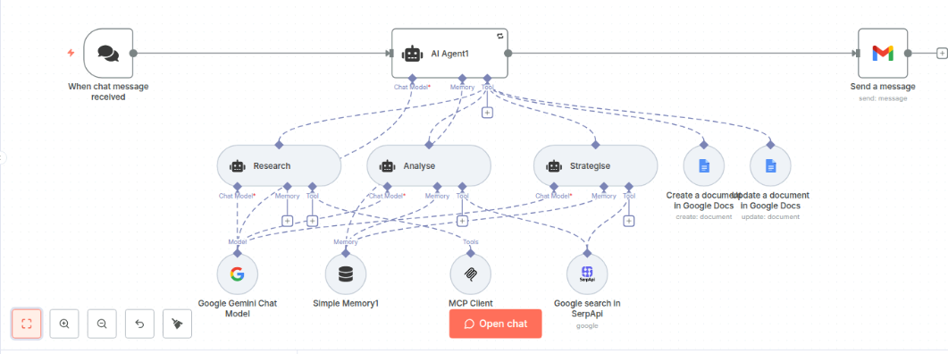

MCP server workflow
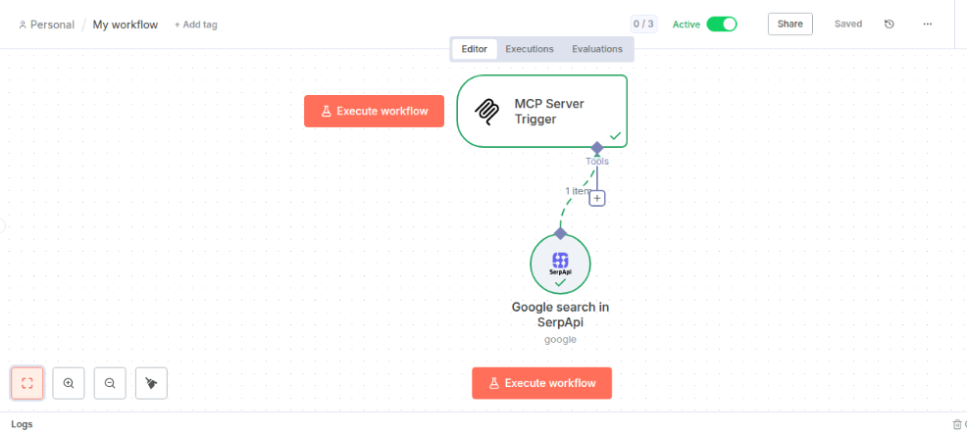

CrewAI Project Setup Steps:

- Create a new folder on your Desktop
  - Example: crewai_project

- Open the terminal/console and move to the Desktop: cd Desktop

- Navigate into your project folder: cd crewai_project

- Initialize a new project with uv (replace project_name with your chosen name): uv init project_name

- Move into the project directory: cd project_name

- Install required dependencies:

  - uv add crewai>=0.165.1 crewai-tools[mcp,serpapi]>=0.62.3 fastmcp>=2.11.3 streamlit>=1.48.1 tavily-python>=0.7.11

- Open the project in your editor (Cursor/VS Code/etc.):
  - Example: File → Open Folder → select your project folder

- Add the provided code files (test_crewai.py and server.py) into the project folder.

- Open the code files (server.py and test_crewai.py) and insert your model configuration: Gemini, OpenAI, or Azure, along with the correct API key.

- Open a new terminal inside your editor
  - In Cursor/VS Code: Top menu → Terminal → New Terminal

- Then run this command Set-ExecutionPolicy -Scope CurrentUser RemoteSigned

- Activate the virtual environment: source .venv/bin/activate

- Start the CrewAI backend server: uv run server.py

- Keep that terminal running. Open a new terminal window in the same project folder.

- Run the Streamlit UI: uv run streamlit run test_crewai.py

- Wait for a browser window (Chrome) to open automatically if it doesn’t, copy the local URL from the terminal (e.g., http://localhost:8501) and paste it into Chrome.

- Test the setup by typing a query into the Streamlit app, e.g.: simplilearn vs edureka

